1. **Design DB**

create database phase2;

use phase2;

create table Destination

(

DID int not null identity primary key,

Dname char(30)

);

insert into Destination(DID,Dname)

values

(1,'Delhi'),

(2,'Manali'),

(3,'Rajasthan');

create table Place

(

PID int identity not null,

Pname char(30),

DID int not null foreign key references Destination(DID),

primary key(PID,DID)

);

insert into Place(PID,Pname,DID)

values

(1,'Gaziabad',10),

(2,'Noida',10),

(3,'Solang vali',11),

(4,'Brigu Lake',11),

(5,'Jaisalmeer',12),

(6,'Jodhpur',12),

(7,'Jaipur',12);

create table Plans

(

PLID int not null identity primary key,

PLname char(30) not null,

DID int foreign key references Destination(DID)

);

insert into Plans(PLID,PLname,DID)

values(1,'Delhi plan',10),

(2,'Manali plan',11),

(3,'Rajasthan plan',12);

create table Planperiod(

PeriodID int not null,

noofdays tinyint not null,

PLID int foreign key references Plans(PLID),

primary key(PeriodID,PLID));

insert into Planperiod(PeriodID,noofdays,PLID)

values(2222,1,1),

(2223,12,1),

(2224,2,2),

(2225,10,2),

(2224,5,3),

(2225,6,3);

create table Transpordmode(

TID int not null,

Tname char(20),

PLID int foreign key references Plans(PLID),

primary key(TID,PLID));

insert into Transpordmode(TID,Tname,PLID)

values(3333,'Bus',1),

(3334,'Plain',1),

(3335,'Train',1),

(3336,'Bus',2),

(3337,'Plain',2),

(3338,'Train',2);

create table Planprice(

PPID int not null,

amount int not null,

PeriodID int not null,

TID int not null,

PLID int not null foreign key references Plans(PLID),

foreign key (PeriodID,PLID) references Planperiod(PeriodID,PLID),

foreign key (TID,PLID) references Transpordmode(TID,PLID),

primary key(PPID,PeriodID,TID,PLID));

insert into Planprice(PPID,amount,PeriodID,TID,PLID)

values(998,12000,2223,3334,1),

(999,18000,2223,3335,1)

1. **CRUD Operations**

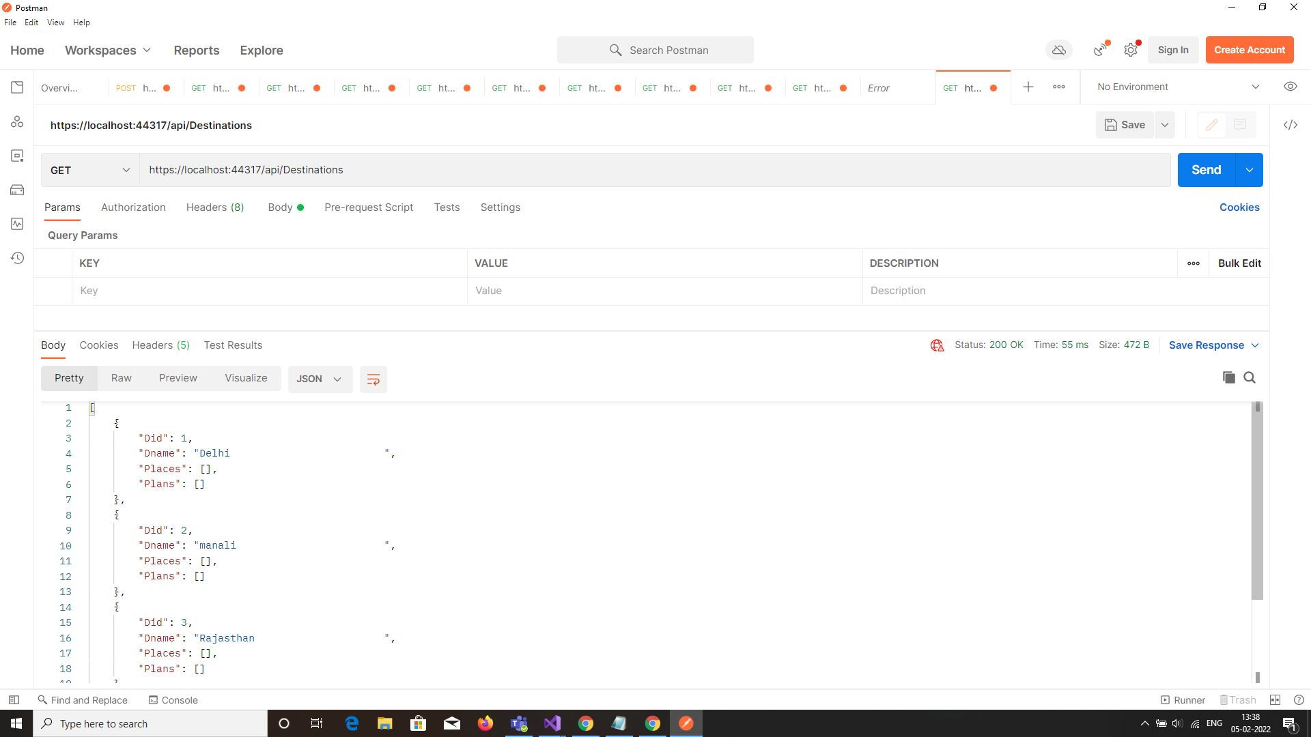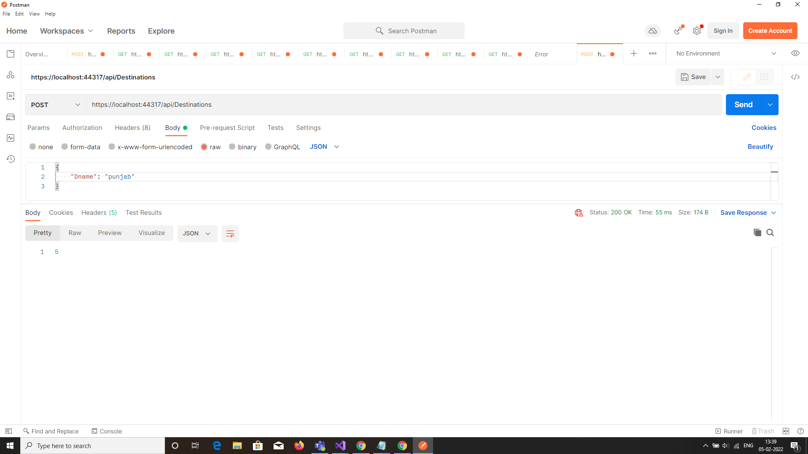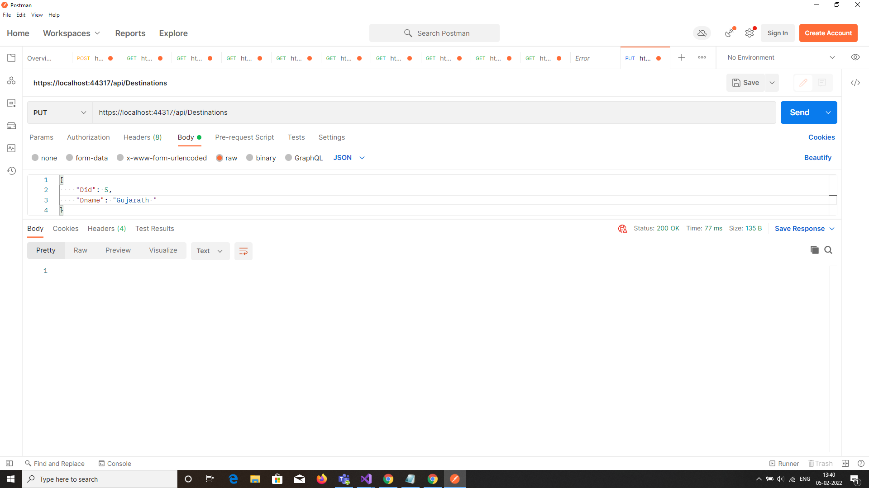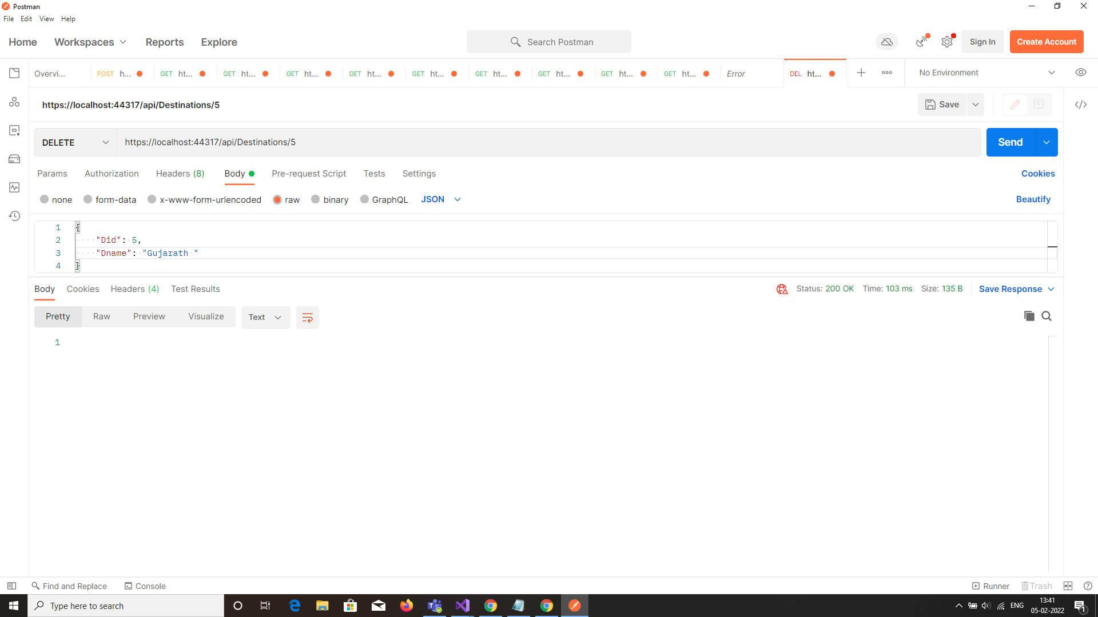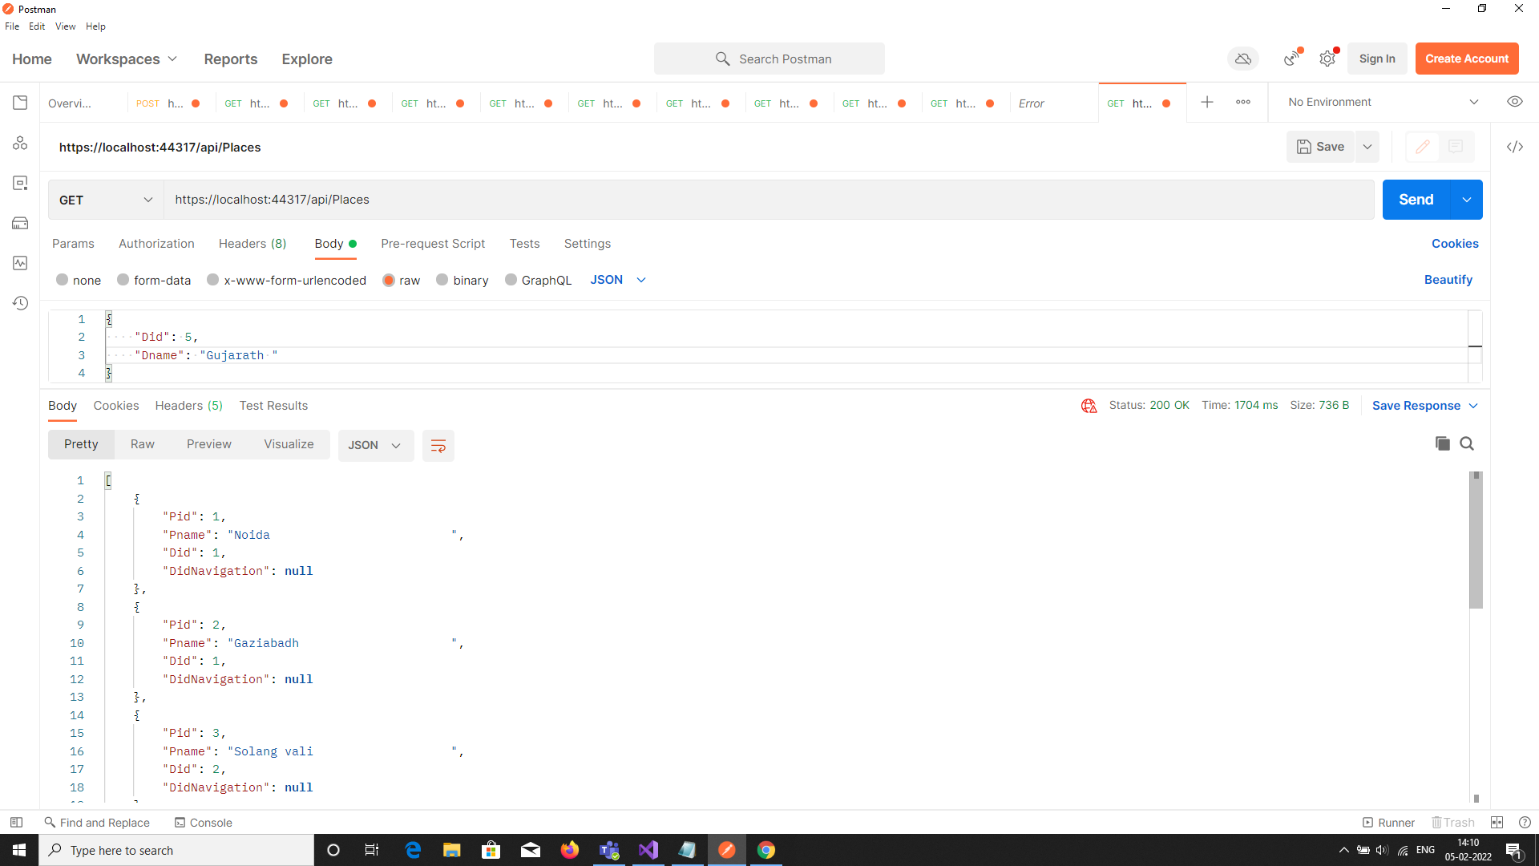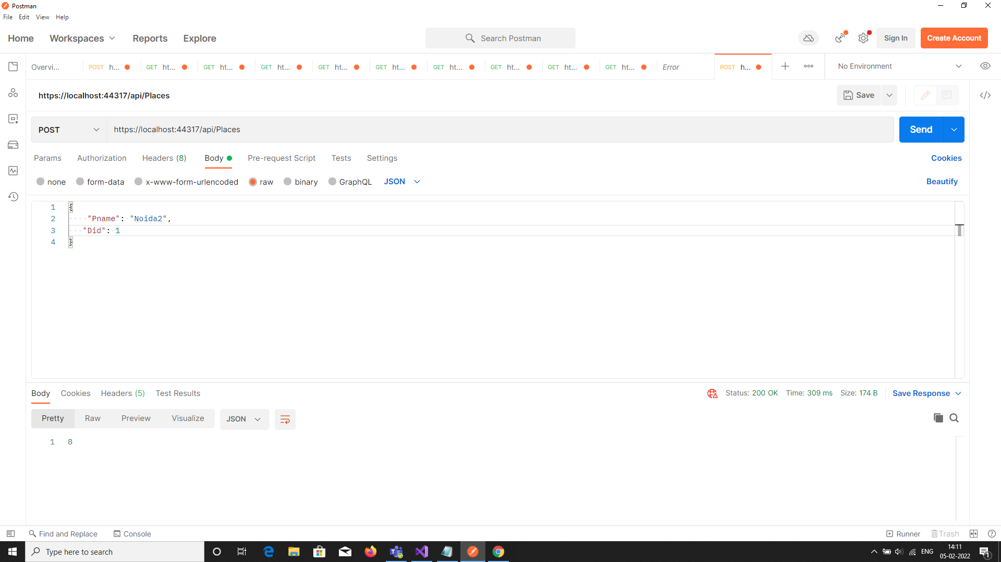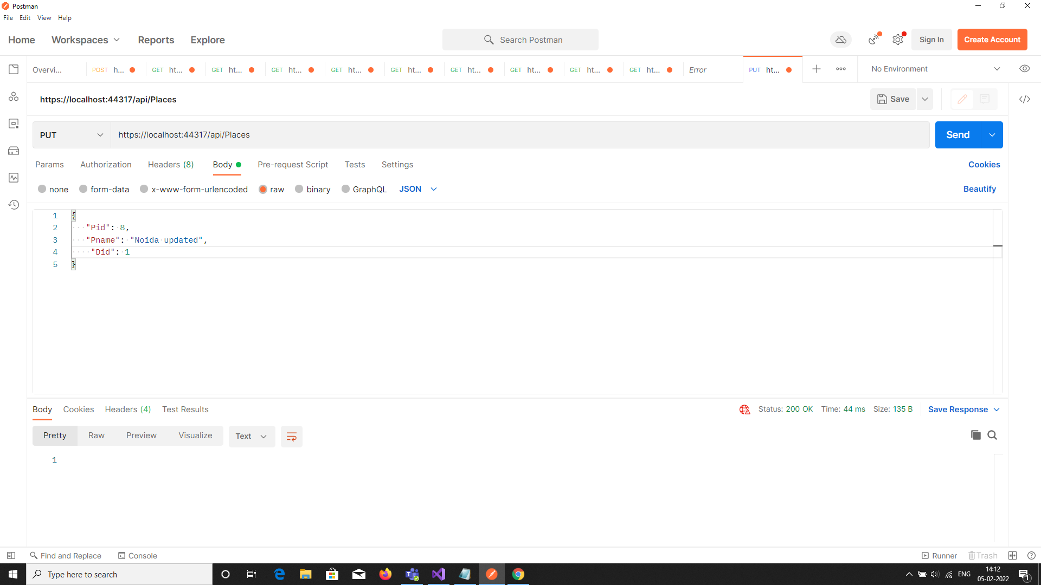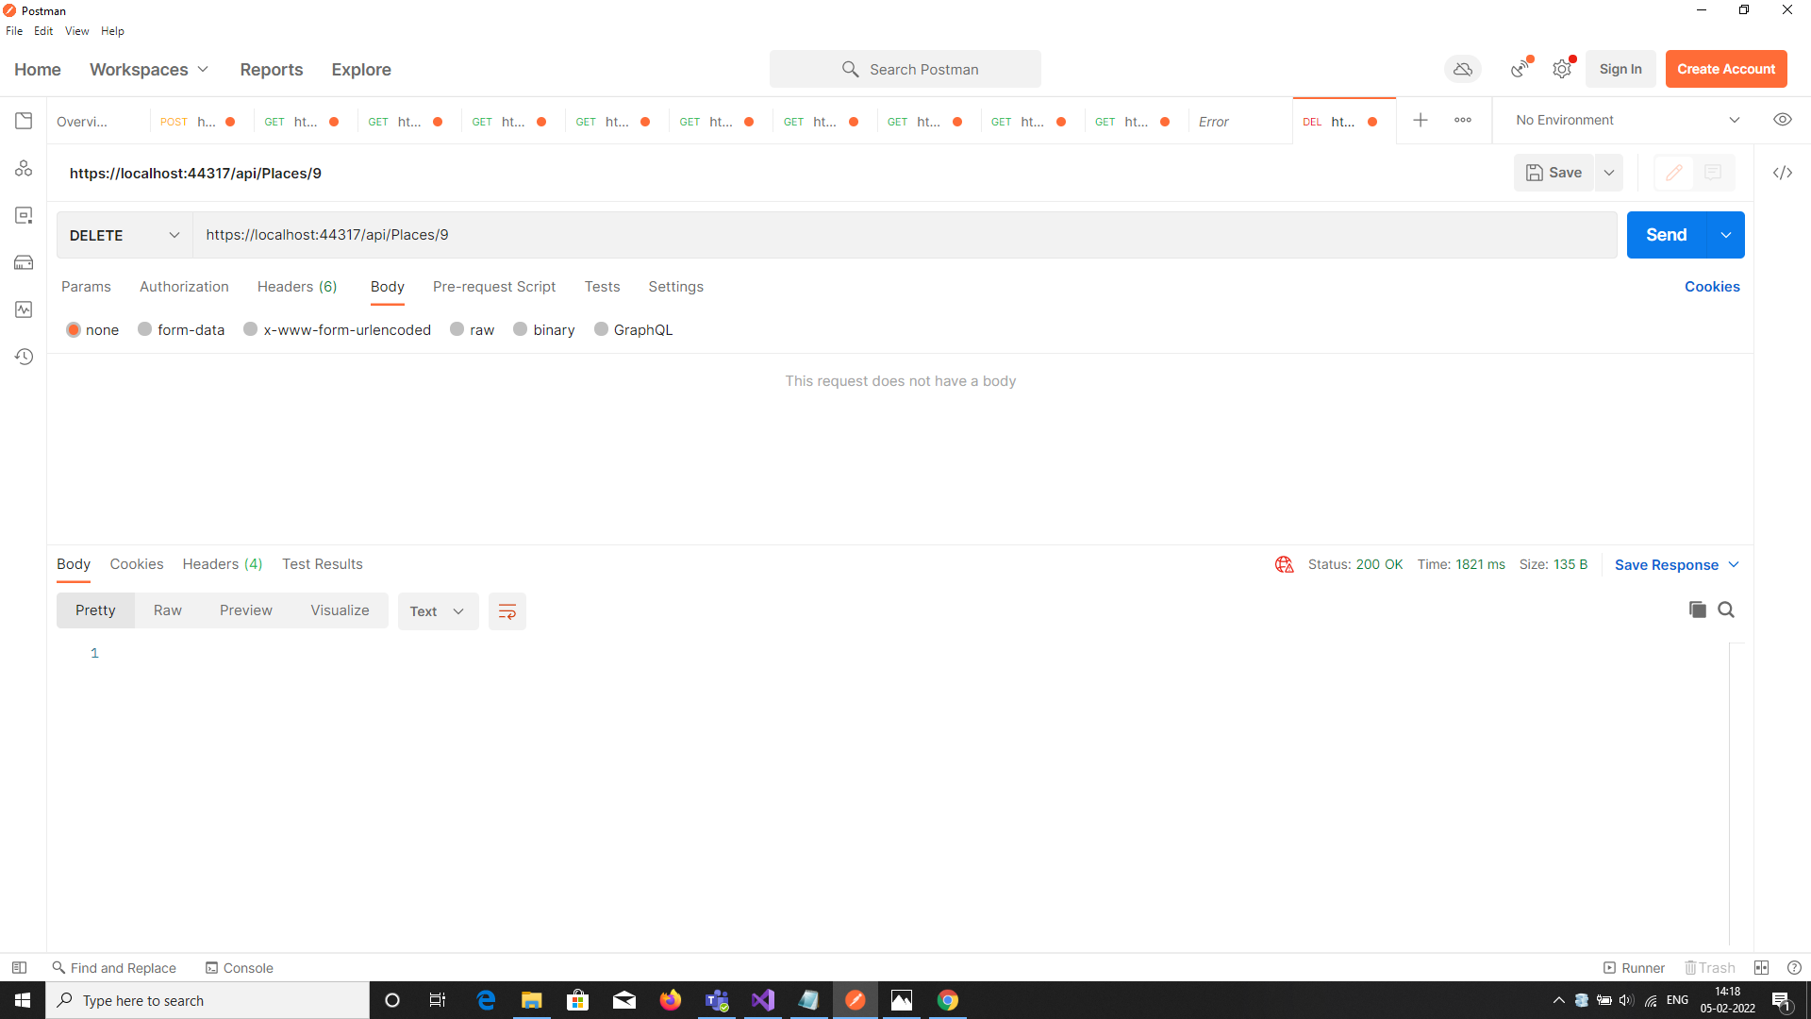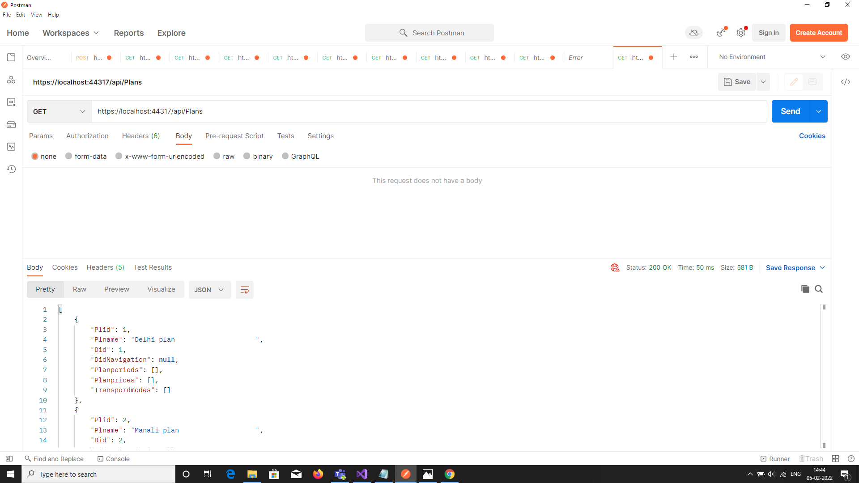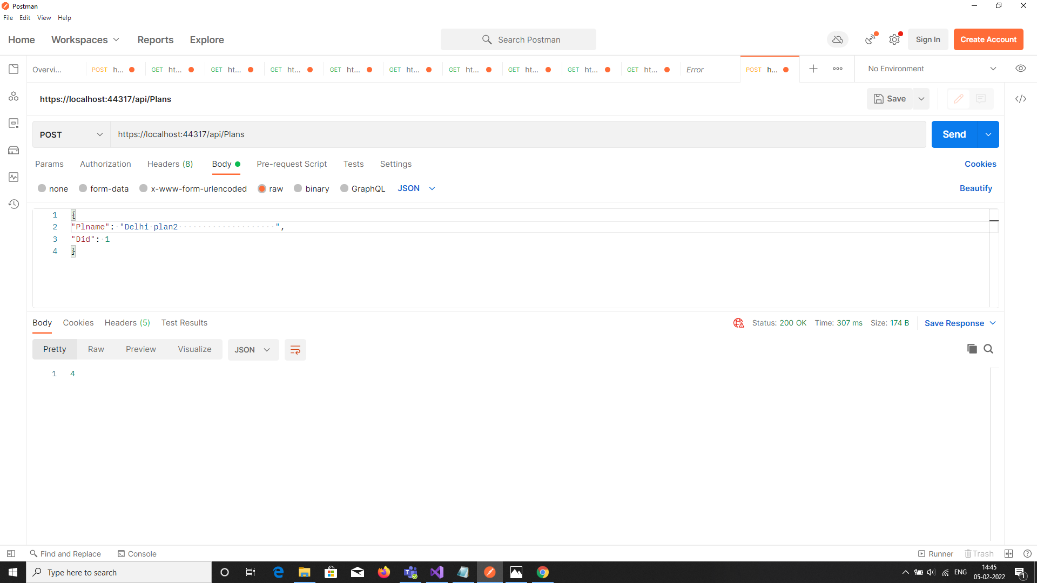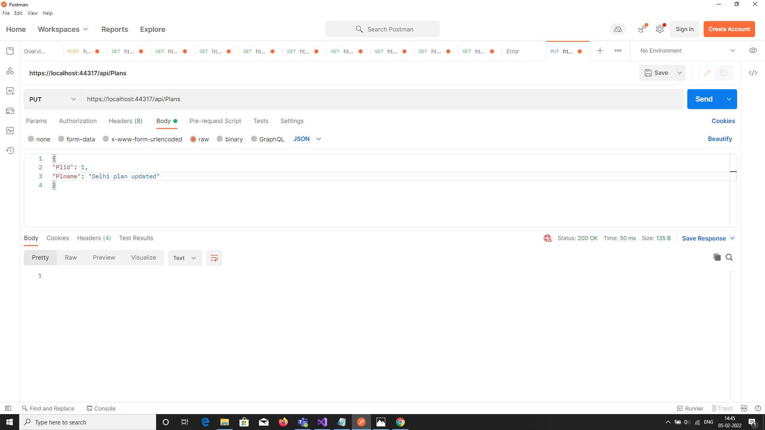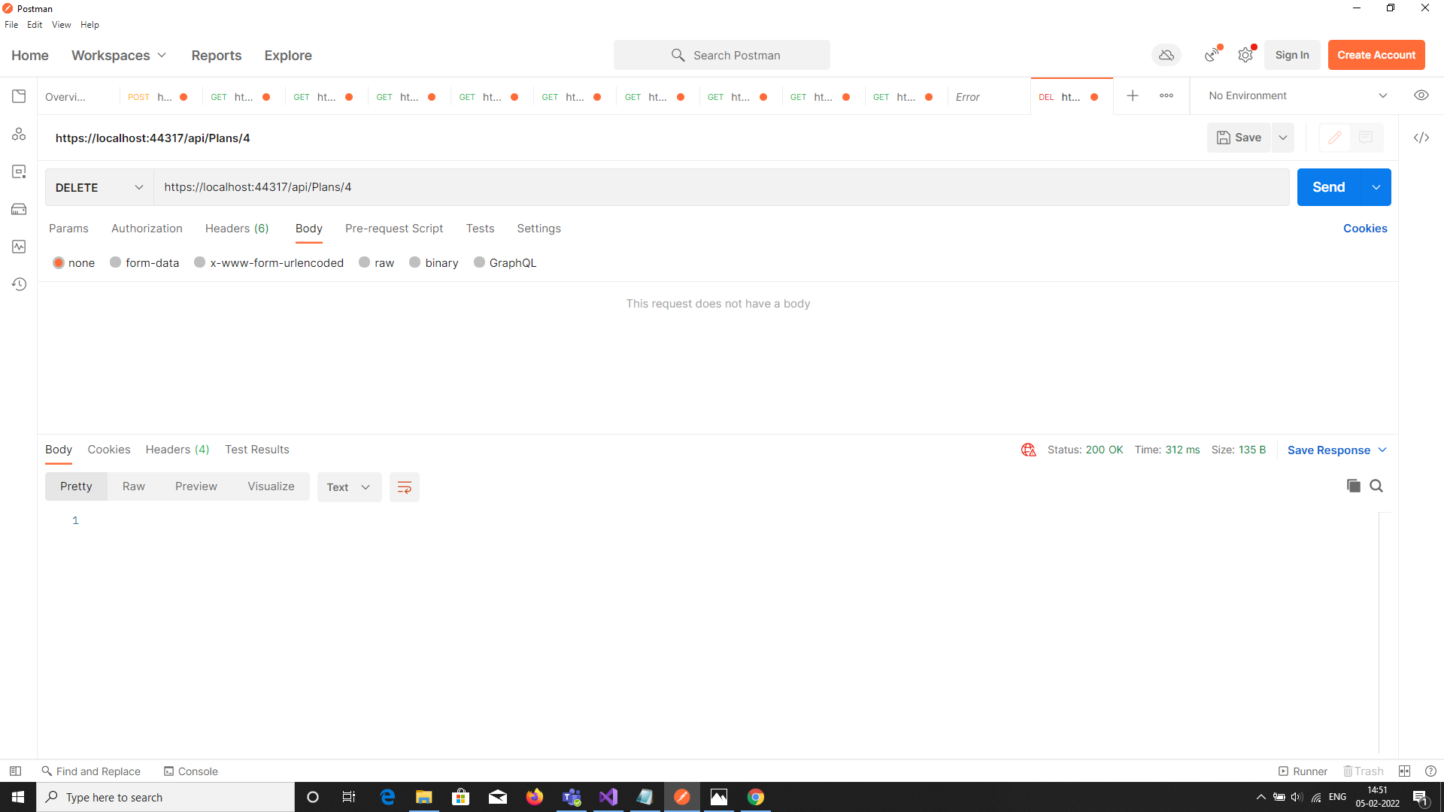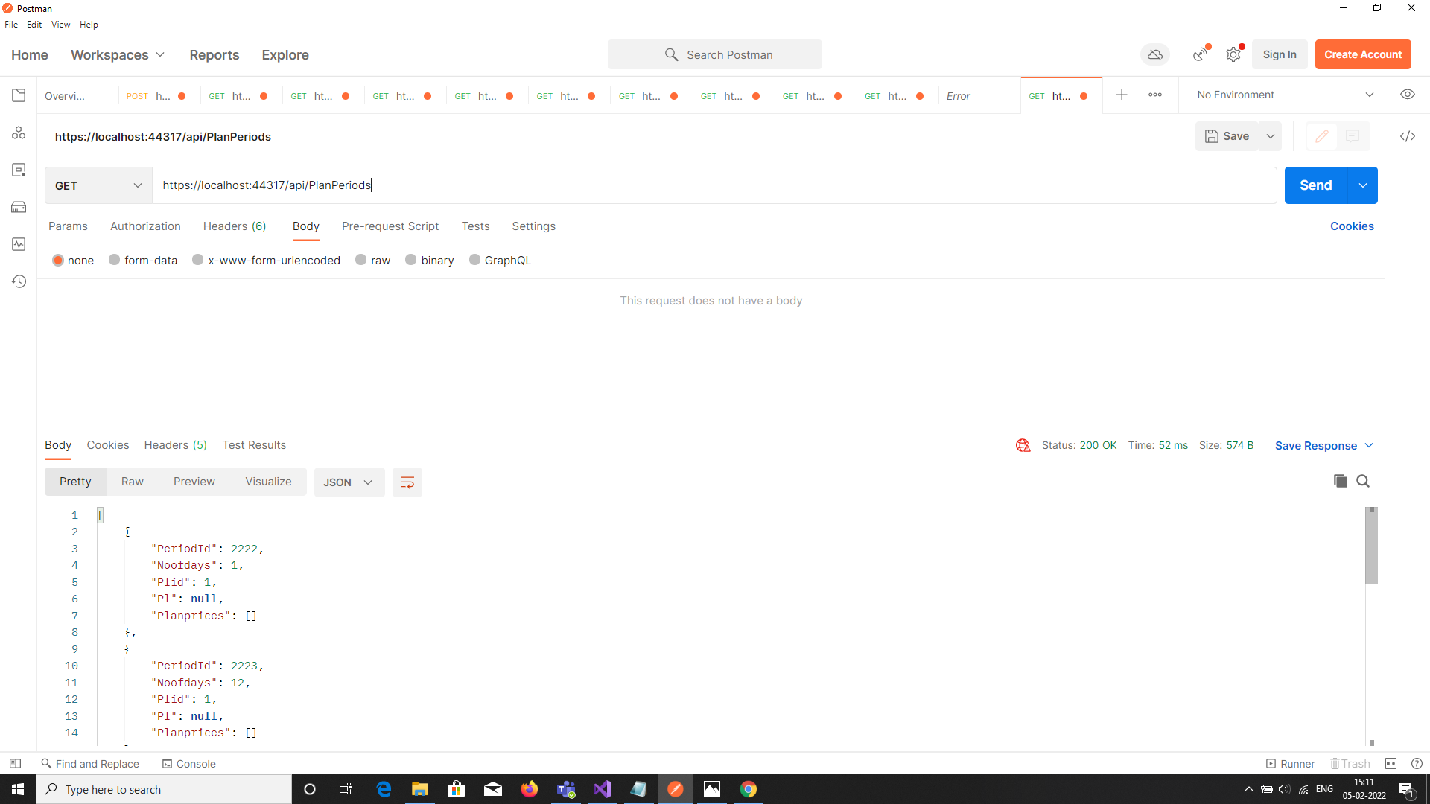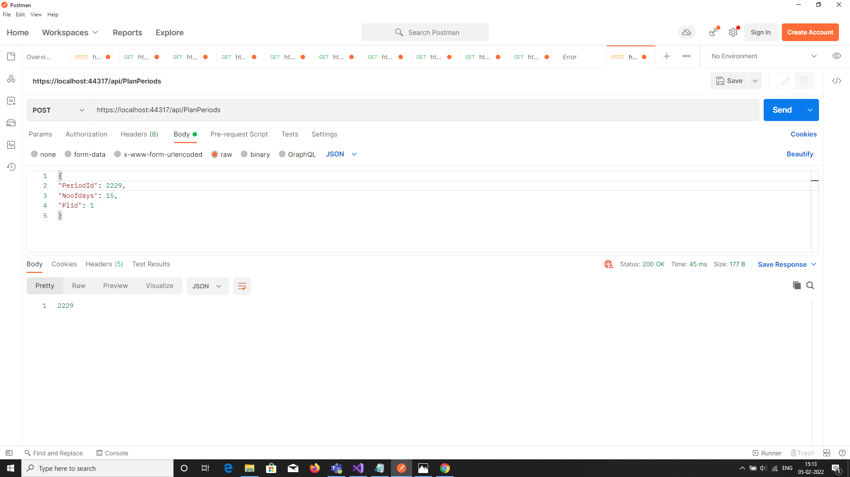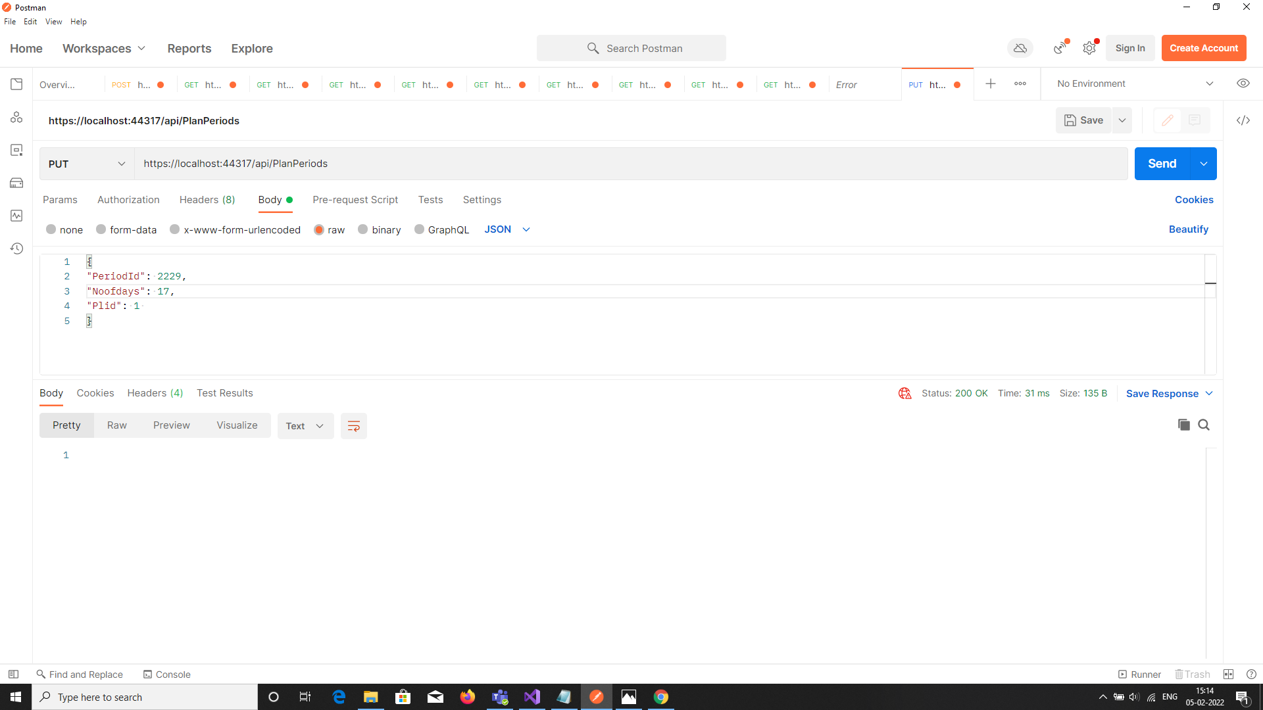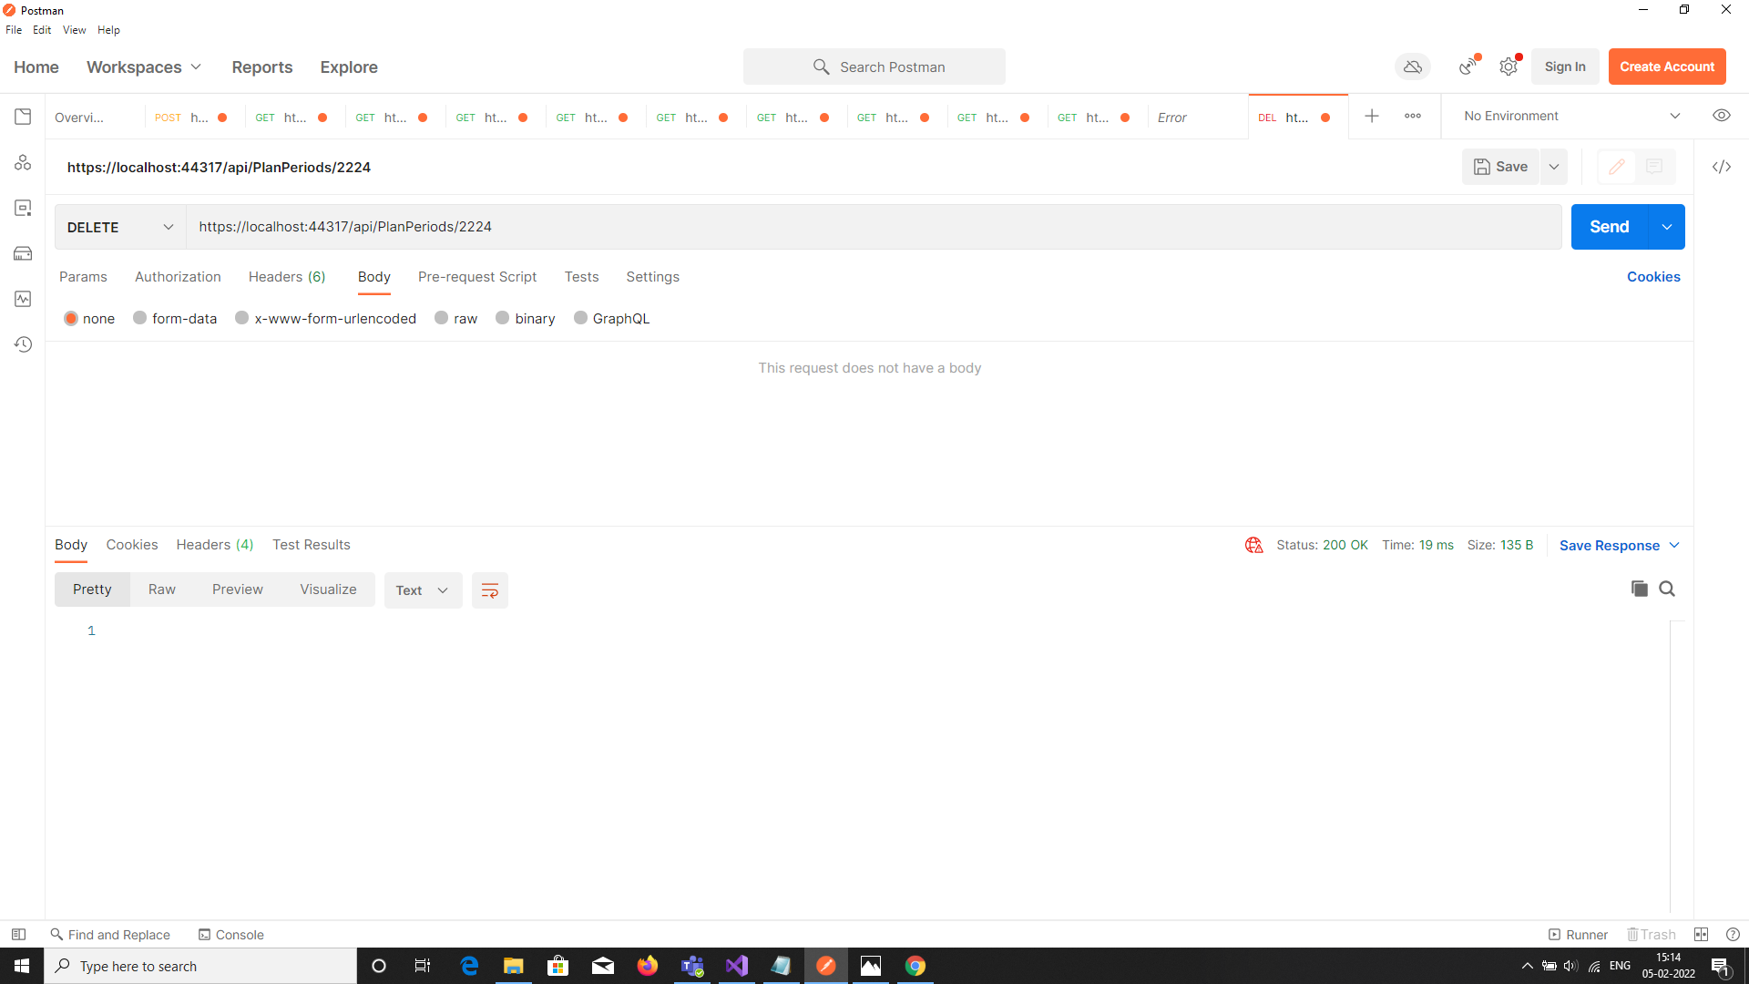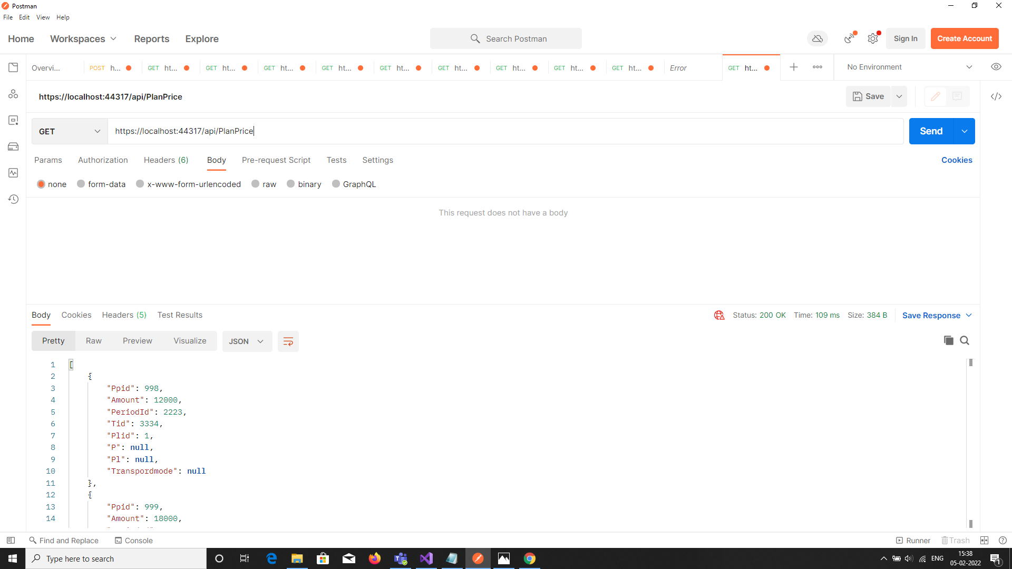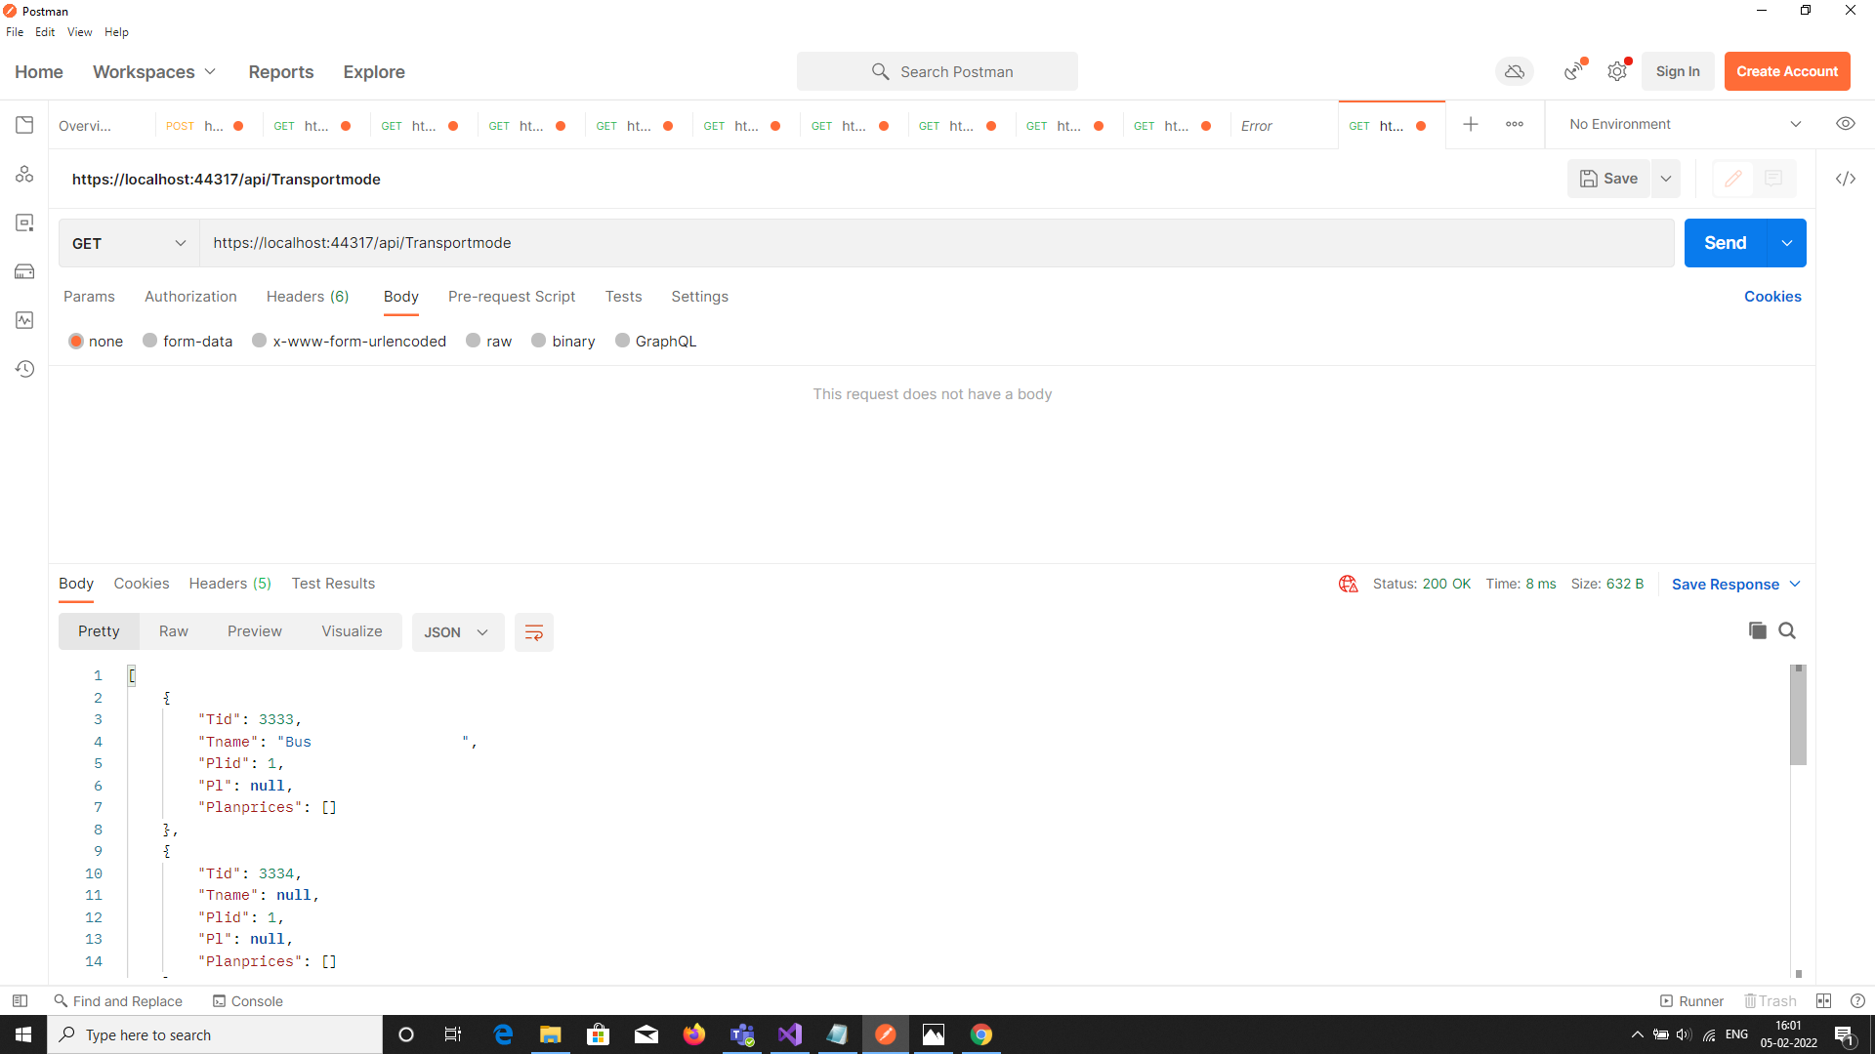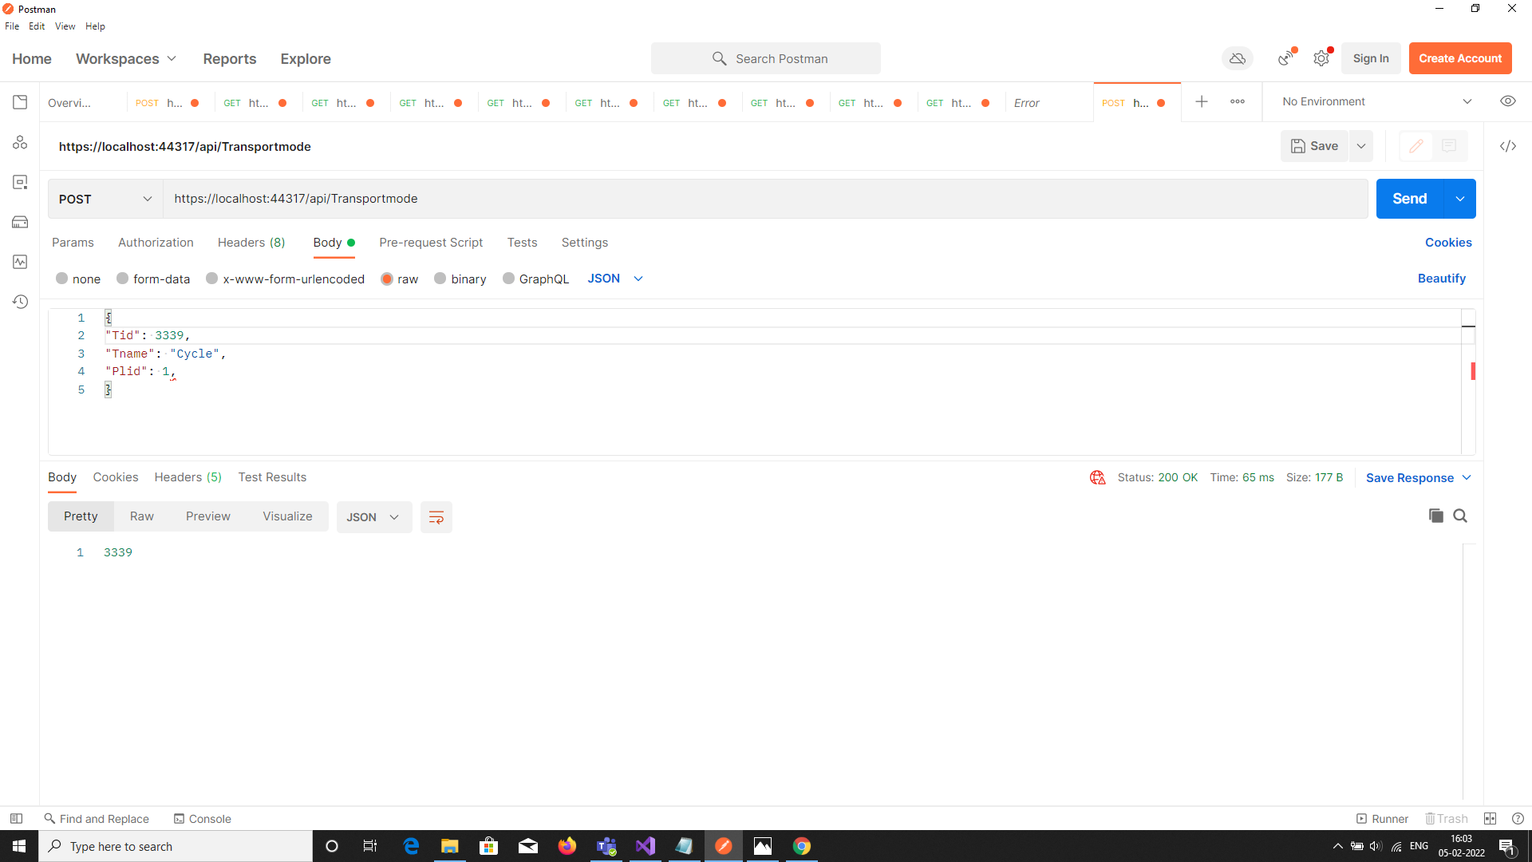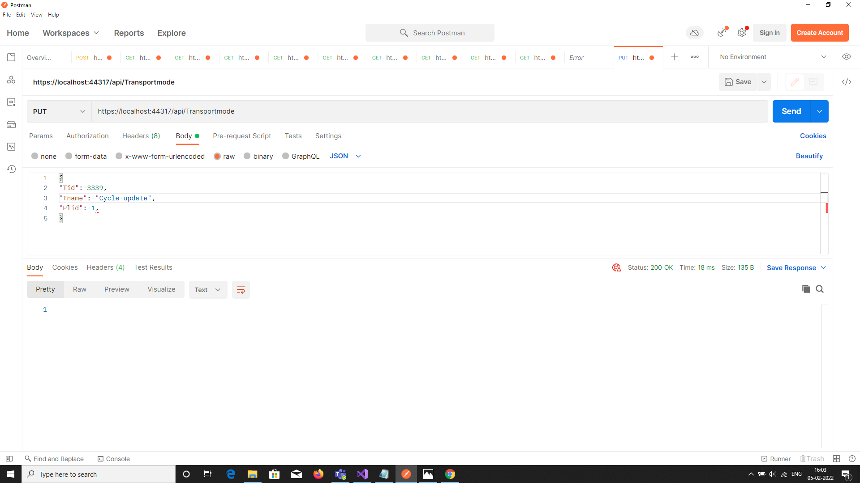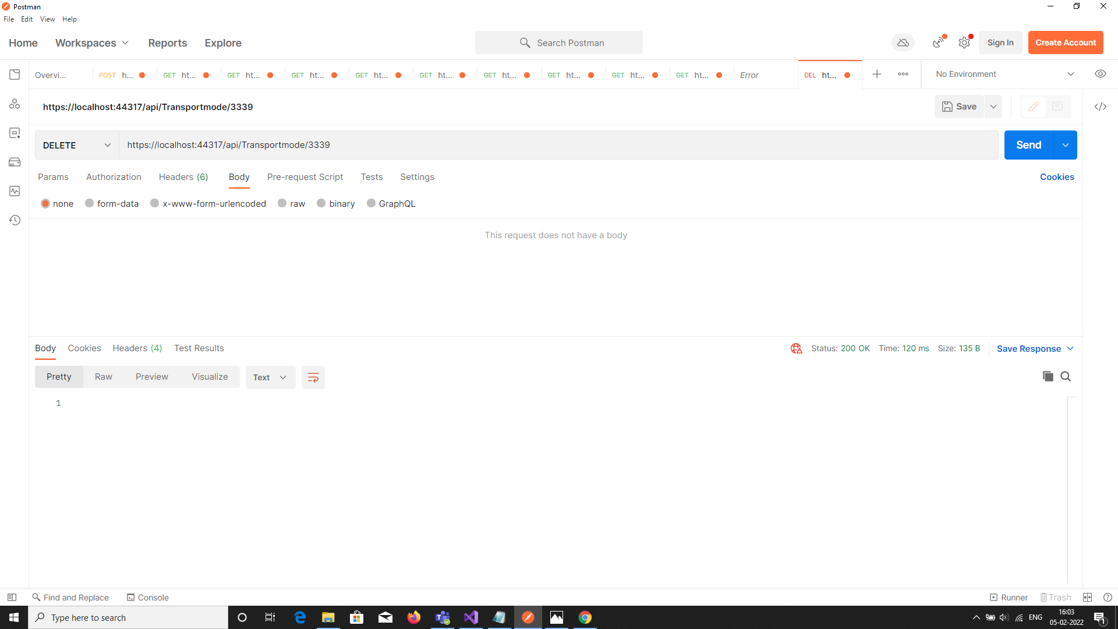

1. **List of all travel plans where period of plan does not exceed 2 days**

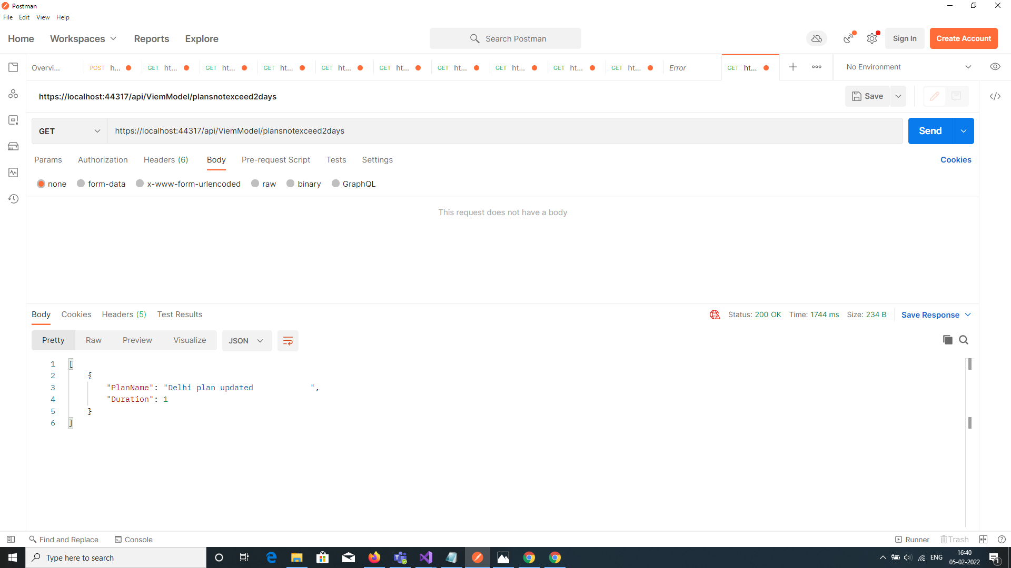

1. **List of all travel plans including name, period, mode of transport, price grouped by plan type**

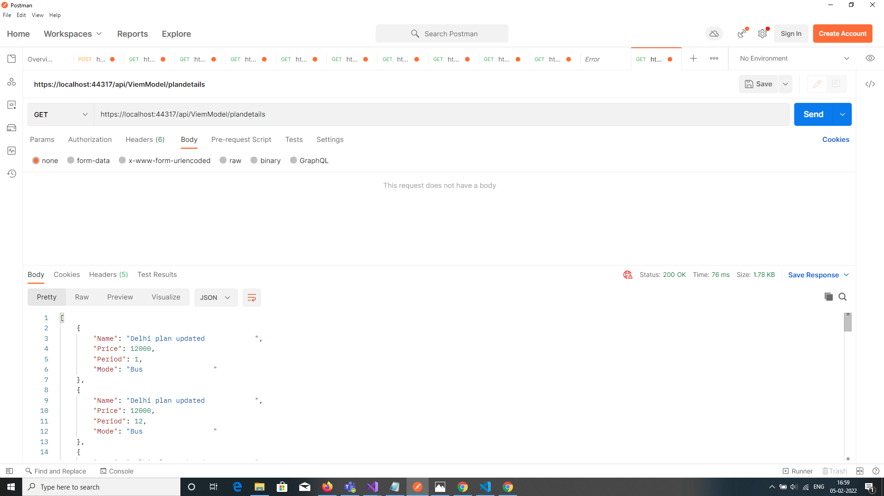

1. **Token Authentication**

